Advertising Class 101

Heads Up!
Wiki is Wicked Under Construction. Please contact Eddie Jones with questions (ejones@ebay.com)

eBay Advertising classify the full suite of products into two buckets as below
Owned & Operated  - All of our owned and operated sites…ebay.com, eBay mobile app, stubhub, Consumer Shopping Sites, Stubhub, “eBay Commerce Network” and PLA.  - We offer both direct and programmatic buying solutions.  EAP  - “eBay Audience Platform” - Gives marketers the ability to connect with eBay users anywhere, anytime, and on any device. And we have display, mobile, video, and social you can take advantage of. | 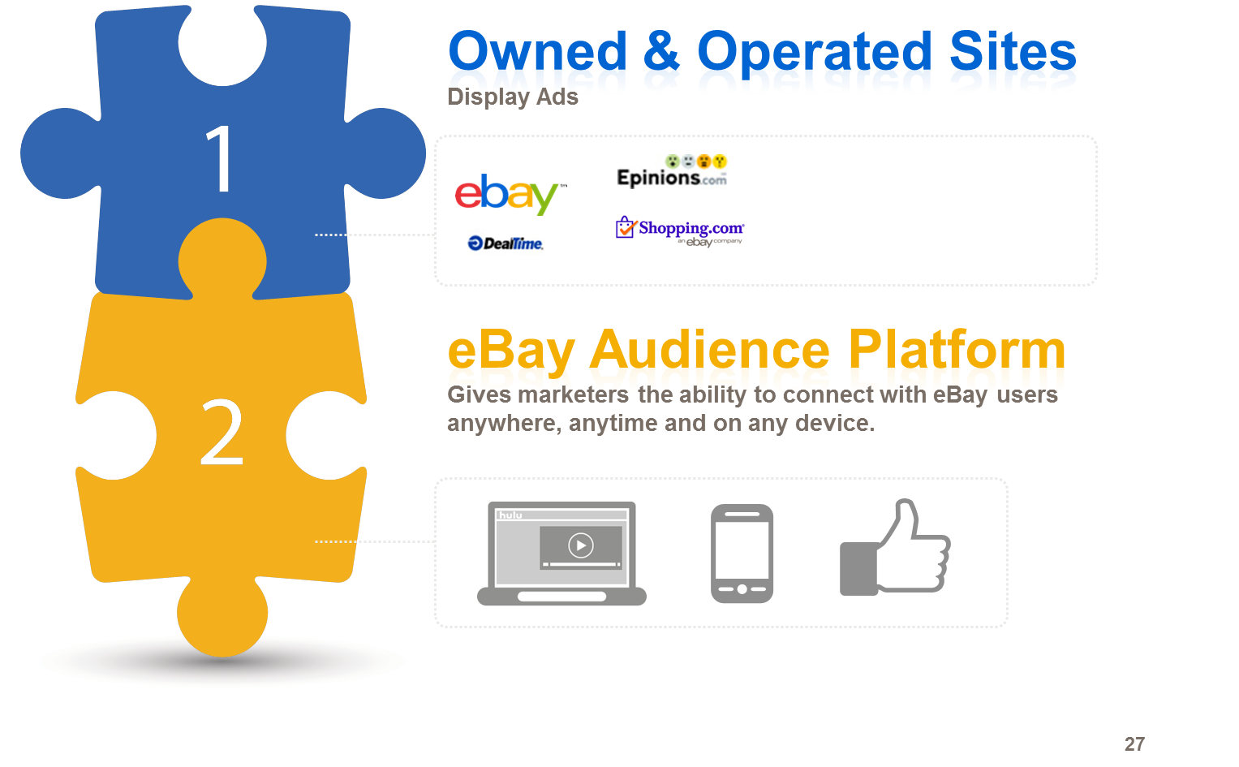

Common O&O Placements

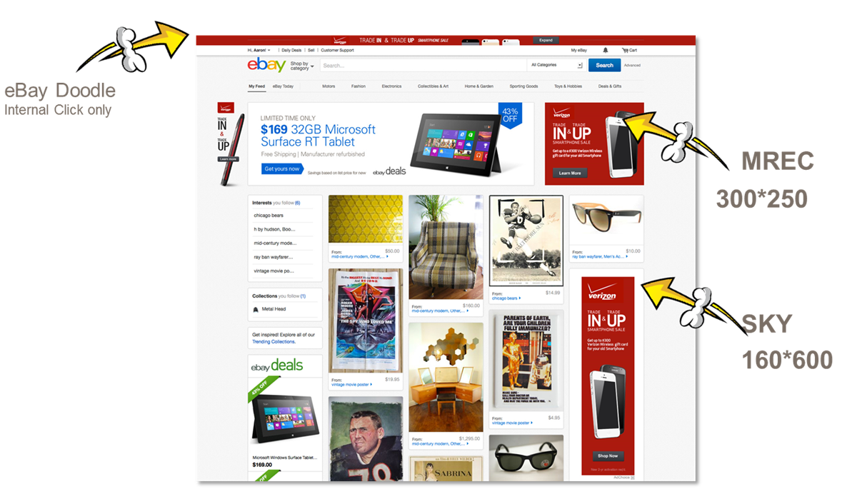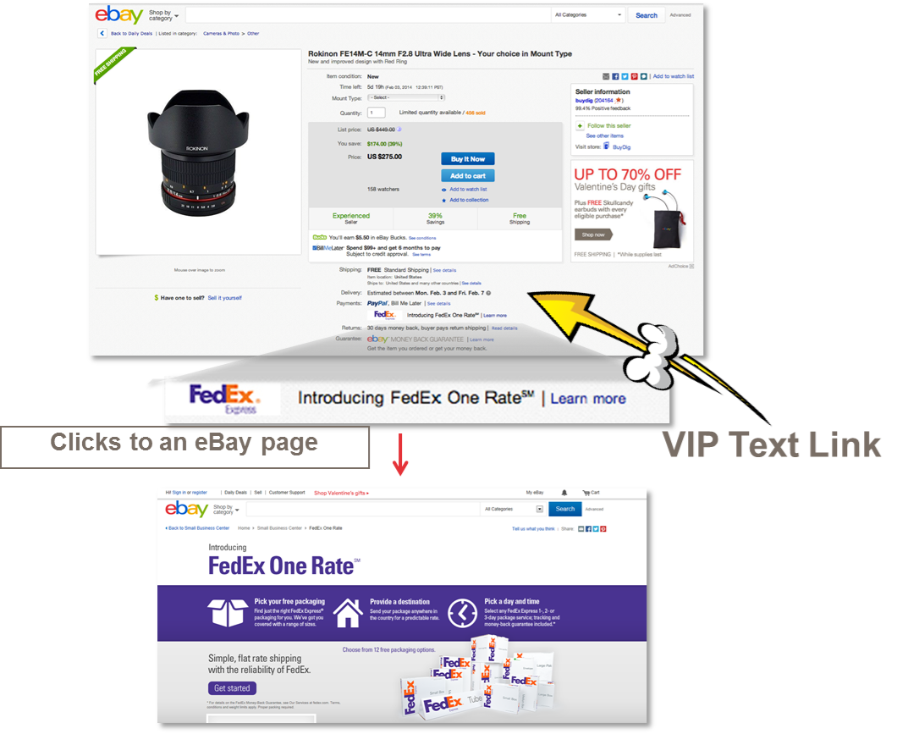

EAP Ads

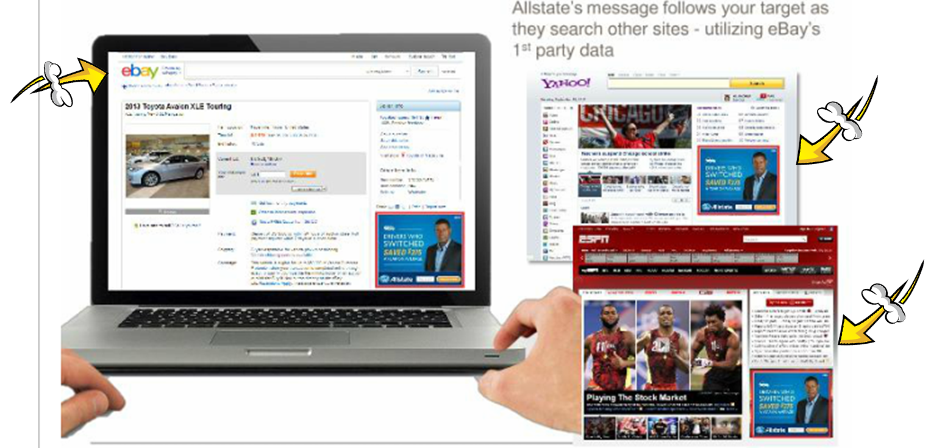
eBay as the ads publisher, where reserves the placements on HP, VIP, SRP for advertisers, and the advertiser decides who gets the impression, or an advertiser's ad server, where the advertiser decides which creative goes in the slot they have been assigned.

AD Serving Process
Ad serving means figuring out which advertisement goes in which ad slot on a publisher's webpage through technological means. (That act of serving of an ad is called an impression.) Most large ad servers also:
- Choose the ad that will most benefit the advertiser or the webpage, and that meets each party's criteria
- Record how many ads were served and on what pages
- Record performance data, e.g. whether the ad was clicked on or if the ad can be tied to a purchase or some other action
- Funnel performance data back into the matching process
- Capture and make available user data, which is information about a consumer (user) including browser habits and demographic data
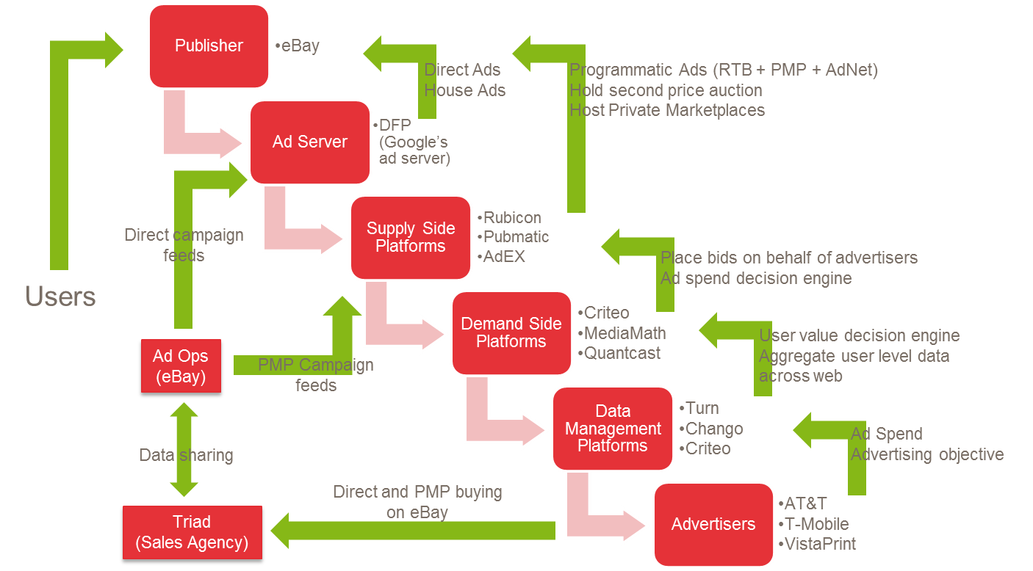

Key external Ad partners are: DFP (Google Ad Server), Rubicon, Pubmatic, AdEX,
Key external Ad partners are: Yahoo, Google, and Shopping.com
EAP Ads partners are: Google, Turn, and Chango

eBay charges on CPM (Cost per thousand impressions) basis as it is closer to an exposure model rather than a direct response one: i.e., they get paid on delivering an ad, not on whether someone clicked on it
Revenue Funnel
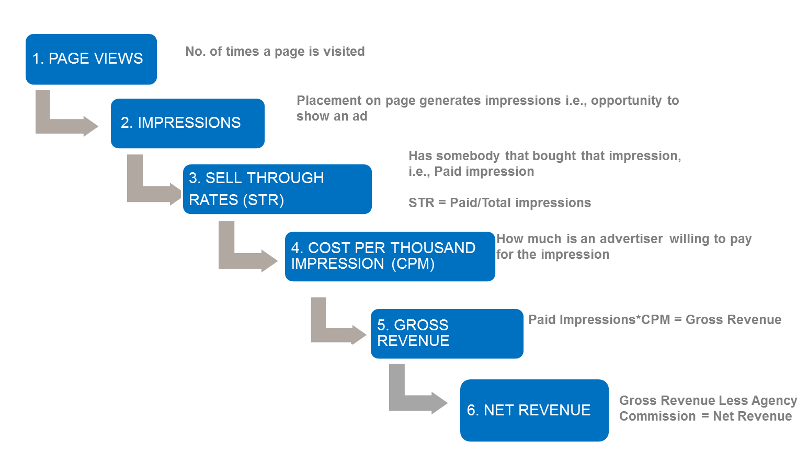

Below are the common acronyms used in the online display and test advertising domain... more on glossary page
Acryonym | Definition
3PA | 3rd Party Ads
PMP | Private Market Place
DSP | Demand-side Platform
SSP | Supply-side Platform
OnO | eBay Owned and Operated
PLA | Product Listing Ad
EAP | eBay Audience Platform
DMP | Data Management Platform
DFP | Doubleclick for Publishers
HP | Homepage
VIP | View Item Page
SRP | Search Results Page
RTB | Real Time Bidding
oRTB | Online Real Time Bidding
IO | Insertion Order
CPC | Cost per Click
AOV | Average Order Value
CPM | Cost per Thousand Impressions
eCPM | Effective CPM
CTR | Click Through Rate
RPM | Revenue per Thousand Impressions
ROAS | Return on Ad Spend
LP | Landing Page
TLD | Top Level Domain
RUV | Registered Unique Visitors
more on glossary page

